**Batch T7**

**Practical No. 10**

**Title of Assignment: Projects using MySQL, NodeJs and ExpressJs, Reactjs**

**Student Name: Shreyash Patil**

**Student PRN: 22510039**

**Problem Statement 1: Personal Task Manager**

**Develop a simple task manager where users can add, edit, and delete their**

**personal tasks. The tasks should have fields like title, description, dueDate, and**

**status (pending/completed).**

**User authentication (JWT-based login/signup).**

**CRUD operations for tasks (Create, Read, Update, Delete).**

**Filtering tasks by status (pending/completed).**

**Allow users to categorize tasks and set priorities (high, medium, low).**

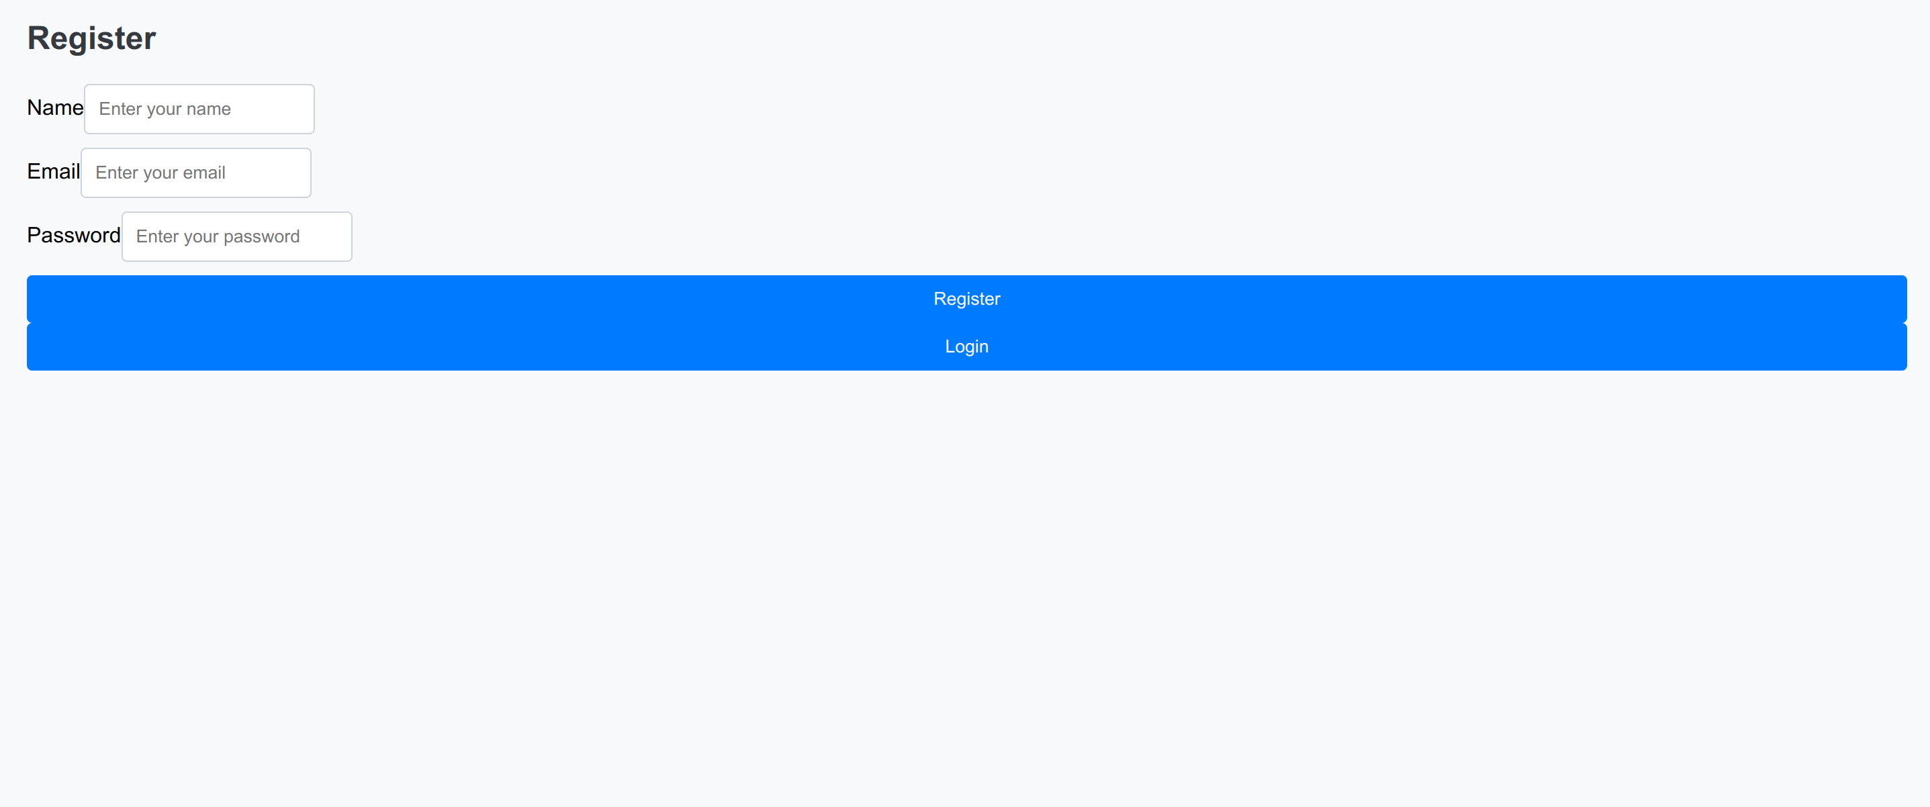**Technologies used:**

* Frontend : HTML, JavScript
* Backend : Node.js, Express
* Mysql
* JWT

**Key features implemented:**

* User authentication
* CRUD (create,read,update,delete)
* Filtering
* Task categorization
* User registration
* User login
* Add task

Get tasks **Problem Statement 2: User Profile Management System**

**Build a profile management system where users can create accounts and update**

**their personal information such as name, email, phone number, and address.**

**User registration and authentication (using JWT).**

**Profile CRUD: Users can create, view, edit, and delete their profiles.**

**Add the ability to upload profile pictures and store the file path in MySQL.**

